Note: The following is an example storm preparedness plan developed by St. Mark’s Episcopal Church, Marco Island, FL. St. Mark’s has been on the track of numerous storms over the years and now has an active team that is prepared to safeguard the campus, check on members, and to support first responders / residents. You may use this as a template and edit as needed.

St. Mark’s 2021 Hurricane Plan
(Draft 7.22.21)
From today until Hurricane Alert is issued

- Five Teams have been formed and developed plans (included).

- Now is the time to prepare, not when we receive a warning. It would also be more effective if members knew ahead of time what their role would be, instead of people sort of guessing and bumping into each other.

- Our primary area of focus should be our Church Campus, Marco Island and East Naples.

- Rector, Wardens, Finance Committee and Vestry should approve the purchase of hurricane shutters for the Rectory as soon as possible. Wardens should be given authority to select a vendor and arrange for installation. This action should be a high priority before xyz date.

- Everyone should keep in mind throughout planning, the hurricane and afterwards, that we must “look out for each other”. Also, throughout “Just look around and see what needs to be done and do it.”

- IMPORTANT: Rector and Senior Warden will decide when to activate this plan. When that happens, they must immediately notify the Diocese that we have activated our plan. Calls should be made to the Diocesan office, xxx-xxx-xxxx and Diocesan Disaster Coordinator, Deacon Michael Sircy, xxx-xxx-xxxx.

- Keep in mind that the Church’s property is secondary to the personal needs and well-being of our members and neighbors.

- It is highly recommended that no one attempt to ride out a storm in any of our church buildings.

- Each critical staff member and key hurricane volunteers should immediately get a laminated letter on Church stationery describing their position and why that is important. It should be dated and signed by Jessica and should be kept in their cars in case they need to come onto the Island following a major storm.

- Hurricane Preparedness Team Plan

Overview of the Plan and items to be accomplished at the beginning of the Hurricane Season:

- Team leader and members:
  - Team Leader: xxx
  - Team Co-Leader: yyy
  - Alternate Team Leader (if x and y are absent): XXX
  - Team Members: …

- The Hurricane Preparedness Team has developed the following plan to protect our campus, buildings and property, including the Rectory in the event of a hurricane. The plan is concerned with doors, windows, valuable property and loose objects on the campus.

- The City of Marco Island will activate the Emergency Operations Center (EOC) when a Hurricane Warning is issued for this area. When the EOC is activated, you may call 230-389-5000 for storm related information or visit cityofmarcoisland.com website for Hurricane Emergency Bulletins and tune in to the City of Marco Island Emergency Radio Station AM 1690. More information can also be found at colliercountyfl.gov under Emergency Management.

- Remember that the Church’s property is secondary to personal needs, safety and well-being of our members and neighbors.

- If approved by the Finance Committee and the Vestry, trees on the church campus and rectory should be given a “hurricane trim”. Also if approved, the rectory should have hurricane shutters installed. The roofs of the church buildings should be inspected annually and any repairs made.

- Rector and Sr. Warden will make sure that St. Mark’s property and flood insurance policies are up to date. The Sr. Warden should keep copies of all current policies and keep the originals in the office safe.

- XXX will work with the Altar Guild to create an inventory of valuable items kept in the Sacristy.

- XXX has recruited volunteers (1, 2, 3, 4, ) who will come to St. Mark’s and help move indoors or secure any items on campus that might be destroyed or cause destruction. There are two working dollies to be used to move heavy items and there is a checklist of items to be moved or secured attached to this plan. XXX will take down the flag.

- Attached to this plan is a utility diagram showing the main water shut-off valve and electrical panels. When the plan is implemented, XXX, or her alternate if she is not present, will turn off the water at the main valve on Bluebird.

- All staff members should have one or two external battery packs for their cell phones. Recommend that all Vestry and Preparedness Team members obtain external battery pack chargers for their cell phones. They can be purchased from Amazon: Portable Charger, KEYMOX, 10000aMh Power Bank with Quick Charge 3.0, $24.03. Walmart also carries a similar charger for $19.95.

- If necessary after a hurricane, we will open our buildings to house about 20 out-of-town workers from bona fide organizations (not unknown individuals). Willis and the Library will be used for sleeping, probably men in Willis and women in the Library. The showers in both Willis and the Sanctuary will be available. When the Marco Island Emergency Operations Center opens, Gail will find out who coordinates the work of these volunteer groups. The Parish Hall will be used for meals and accepting and staging donations.

- Ten moving blankets to cover the organ, the altar and both pianos have been purchased and are stored in the left Sacristy.

- XXX will purchase and store bottled water in the Parish Hall. She will also work with the Hurricane Assistance Team to provide meals to volunteers and others after the storm.

- Rev. Jessica is crisis trained.

- When a Hurricane Warning is issued for Marco Island (usually 36 hours in advance) and the Rector and Sr. Warden advise, this plan will be activated.

When a Hurricane Warning is issued for Marco Island and/or Collier County, the Hurricane Preparedness Plan will be activated by the Rector, Sr. Warden and Jr. Warden, as follows:

- XXX will notify all Vestry members and all members of the Hurricane Preparedness Team. See attached list of names and phone numbers.

- XXX will verify that the Rector, Senior Warden and Hurricane Preparedness Team Leader have Insurance information in hand.

- XXX will turn off main water valve on Bluebird Avenue.

- XXX will mobilize her volunteer group to put all loose exterior furniture into buildings and take flags down. They will clear courtyard and campus of all moveable unattached items, including hoses and flowerpots that can be picked up and the recycling bins at kitchen door. There is checklist of items to be secured or moved attached to this plan.

- The Babcock’s will move chairs / flowerpots at the Rectory’s exterior door inside. The Babcock’s can manage this themselves.

- Rev. Jessica, 1, 2, and 3 will move all valuables from Church and Bedell Chapel and place them in either the right or left sacristy. The right sacristy can be locked so any valuables should be placed there. They will put other items in the left sacristy. They will cover the altar, piano and organ with moving blankets that have been stored in the left Sacristy. XXX and YYY will take pictures and note on the inventory the items locked up. XXX, XXX and XXX will safely store all valuable items in the Parish Hall, Willis Ministry Center and VPK. The Babcock’s will handle valuables in the Rectory.

- XXX and YYY will lock all doors and windows on the campus. They will also check the two padlocks on the interior doors of the Storage Shed and move the chain saws to an accessible location outside of the Storage Shed indicated by XXX.

- XXX will check all refrigerators and freezers and remove food that will spoil or rot if the power goes out for more than 24 hours.

VPK responsibilities:

- XXX will put orange rocking toy and wooden bench on playground in building.

- She will latch all gates & lock all doors.

Rectory

- XXX will contact the Rector to see if they need any assistance preparing the Rectory for the storm.

- If Rev. Jessica leaves the Island, she will turn off the water at the main valve.

- If Rev. Jessica decides to ride out the storm, she will make sure the Rectory has non-perishable food, battery-powered lights and fans, coolers with frozen water in jugs, etc.

Altar Guild

- Any objects of value are to be locked in the right Sacristy. XXX, YYY and ZZZ will secure those items, document the inventory with photographs and cover the altar, organ and piano with moving blankets.

2021 HURRICANE PREPAREDNESS TEAM MEMBERS
CONTACT LIST
Name Contact Phone Contact email

2021 CAMPUS HURRICANE CHECKLIST

Courtyard
- Fire Pit_____
- 5 benches____
- 5 small pots_____
- Phyl Nairn Sign_____
- 2 cranes_____
Most pots too heavy to move.

Parking Lot/6th Avenue Side
- Secure doors by dumpsters_____
- Hose brought in?_____
- Basketball hoop lowered to lay flat on ground if possible _____

Walkway from 6th Avenue to Church
- Bring in Recycling Bins by kitchen door_____
- Plants outside Red Sanctuary doors_____
- Bench outside Parish Hall doors_____

Collier Parking Lot
- Flags on flagpole _____

Pet Garden/Asian Garden
- 2 planters_____
- Hose?_____
- Buddha lowered to ground? _____
- 3 planters?_____
- St. Francis under pet memorial sign_____

Playground
- Rocking toy
- Mats should be okay (didn’t move during Irma) _____
- One bench_____
Community Gardens
- Ensure there are no small projectile items in individual gardens _____
- Rakes, shovels, hose, watering cans near compost bin_____

Walkway between school and office
- St. Francis statue near turtle _____
- Bench outside preschool door _____
- Hoses?_____
- Pots, turtle, and rabbit are too heavy to move.

ST. MARK’S UTILITIES DIAGRAM
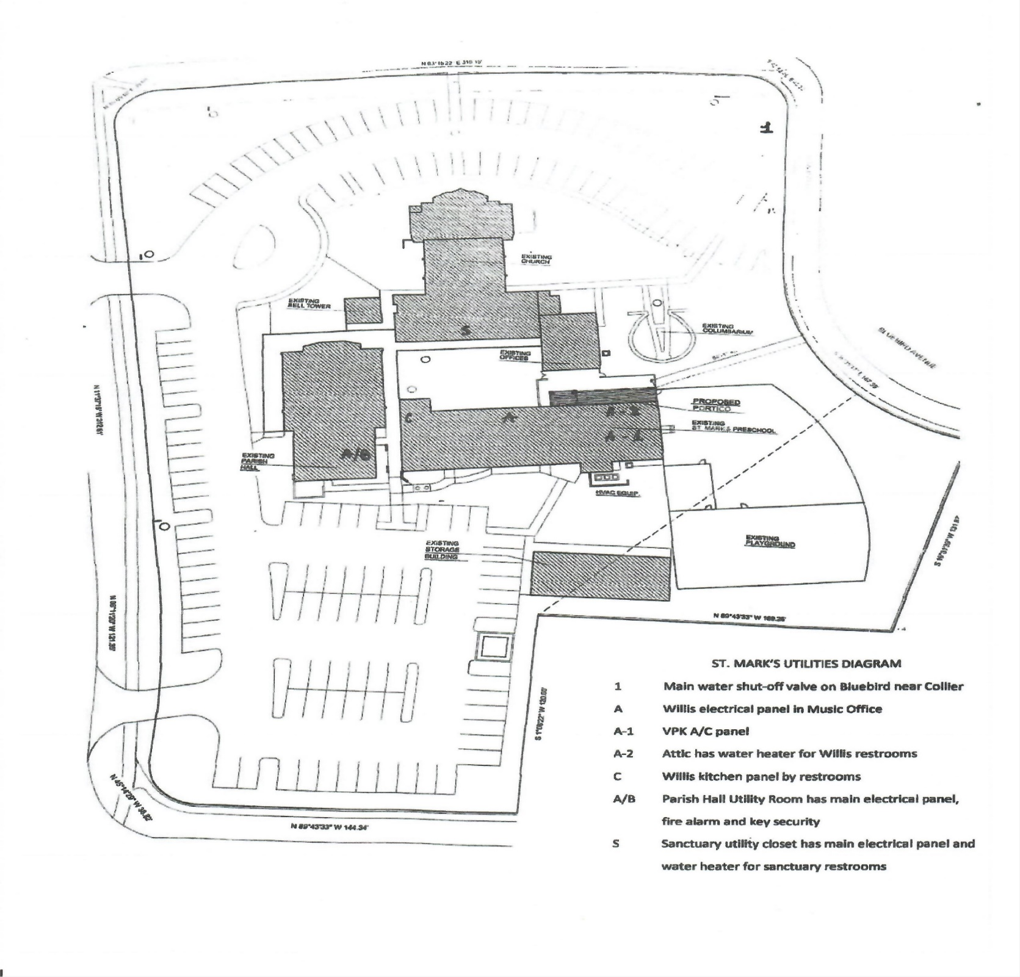

- Church Office Team

- Team Leader: XXX
- Team members: …..

- Team should prepare plans to move the Church Office to another location if it appears that the Church Office may sustain serious damage.

- Directory of Parish Members must be kept up to date at all times, including where members will be during hurricane season.

- All computers, records and systems should be constantly backed up on site and in the cloud.

- Insurance policies and contact information for the Church insurance agency should be kept along with copies of other important documents in a cloud-based e format for remote access. Two or three people should control access – Rector, Church Administrator and Treasurer.

- Team should prepare a traveling kit that includes:

  - Minimal supplies needed to establish the Parish Office in safe location.
  - Master copies of all important documents in hard copy and in the cloud.
  - All important financial records to include pledge and payment records.
  - Copies of the following original documents should be stored together and be ready to be moved ahead of a storm:
    - Articles of incorporations
    - By-laws
    - Insurance policies
    - Minutes of Vestry meetings and Annual Meetings for past two years
    - Parish Record Books and Service Attendance Books
    - Parish Directory
    - Computer passwords, communication system passwords.
    - Emergency contact numbers.
    - Copies of key financial records

- Prepare an EMERGENCY EVACUATION BOX. Attachment A to this Plan.

When a Hurricane Alert is issued for Collier County

- Church administrator should be sure ALL computers are backed up. If we don’t have it already, we should have a cloud-based remote back up program. Should establish who has access to the cloud-based records, etc.

- List of Vestry members’ addresses and phone numbers should be put in safe and in the cloud.
.
- Official records of members in safe and in the cloud.

- Computers backed up off site and in the cloud.

- Hurricane Recovery Team

- Team Leader: xxx
- Team Members: ………..

- Securing the Church should be this Team’s top priority.

- Select and organize a team to clean up Church property after the hurricane has passed. Make sure the Team has adequate equipment and it is in working order. The Church has one chain saw in working order. It is recommended that we do not purchase more chain saws. Team should decide who is authorized to use the chainsaw.

- Take videos and photos of all properties inside and outside prior to a hurricane alert being issued. Photos should be stored in the official cloud-based files.

- Prior to a Hurricane Watch being issued, develop a list of general contractors and tree removal contractors to repair our campus in stages following a storm.

- Keep in mind that there will be immediate short-term recovery AND long term recovery.

During the aftermath of a Hurricane which has struck Collier County

- Put plan into action.

- Secure the Church and Rectory properties.

- Be aware that access to the Storage Shed through the garage doors will not be possible if power is out.

- Take videos and photos of all properties outside and inside, whether we see damage or not.

- Immediately notify the Insurance Company and the Diocese of our situation and request immediate response from both.

- If power is out, access to equipment and chain saw in the Storage Shed will be through Our Daily Bread food storage area.

- Hurricane Assistance Team

- Following a hurricane, our neighbors and members need our help.

- Hot meals served through our kitchen to hurricane helpers and residents of Marco Island and surrounding area who need and would appreciate a hot meal.

  - XXX suggested this important ministry and will take the lead in getting it organized.

    - XXX will research recipes that can easily be prepared in our kitchen using non-perishable food.

    - XXX will stock the Kitchen Pantry with food that can be used for these recipes.

    - She will encourage members to donate food and/or cash that can be used to purchase this food.

    - She will make sure that our grills are in working order and that the propane tanks are full. They will be used in case power goes out.

    - XXX will organize a team ready and willing to prepare and distribute these meals.

    - XXX will need help getting the message out before and after a hurricane that these meals are available and when.

    - XXX and her team will, as they always do, make sure that everything in the kitchen is very clean and all the food is safe.

    - Contingency plans should be made in the event the glass doors are destroyed in a storm.

- Following a hurricane, this Team (XXX and others) should be in touch with the Pastoral Care, Prayer and Member Connection Team to see which members need assistance.

- We should work with Our Daily Bread Food Pantry and Al's Pals to get them donated food and help them get supplies to people in need.

- We could check to see if the Churches on the Island have plans to work together before, during and after a major storm. If so, what is our role? Rector could reach out to the association of Island pastors.

- Hurricane Pastoral Care, Prayer and Member Connection Team

- Team Leader: XXX

- Team Members: …….

- Prepare Vine article now about hurricane preparedness and our Hurricane Team. Put cell numbers of Rector and Sr. Warden as primary emergency contacts during a storm.

- Team currently has a list of contact information for widows, homebound and singles to call in the event of an approaching hurricane. They will ask, “What are your plans and how can we help?”

- 1, 2, 3, 4 and 5 will make these calls.

- Prior to any storm, another email goes out to all members asking them to notify us if they need assistance. We will also provide the Rector’s and Sr. Warden’s cell numbers for emergency contact.

- Before, during and after the storm, we will provide prayers for our members. This will be done using our intercessory prayer team email list.

- Each member of the Team will have an up-to-date member directory.

During the aftermath of a Hurricane which has struck Collier County

- Team Lead will put plan into action beginning with team phone calls to homebound/widowed/singles.

